实验九：window与document

1. 完成登录页面（页面中有三个按钮：用户登录、用户注册、退出）单击“用户登录”时，当页面的分辨率为1024*768时跳转到注册页面，单击“退出”按钮时，弹出对话框问是否退出，单击确定时，退出当前窗口





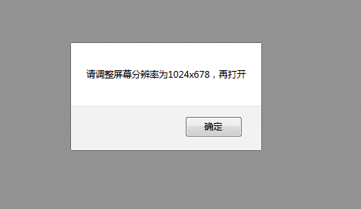

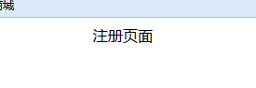

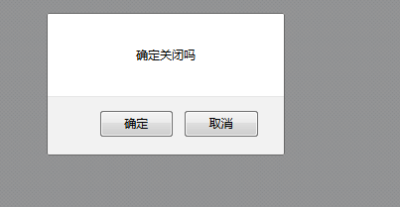

1. 页面加载时打开广告页面，2秒之后广告窗口自动关闭

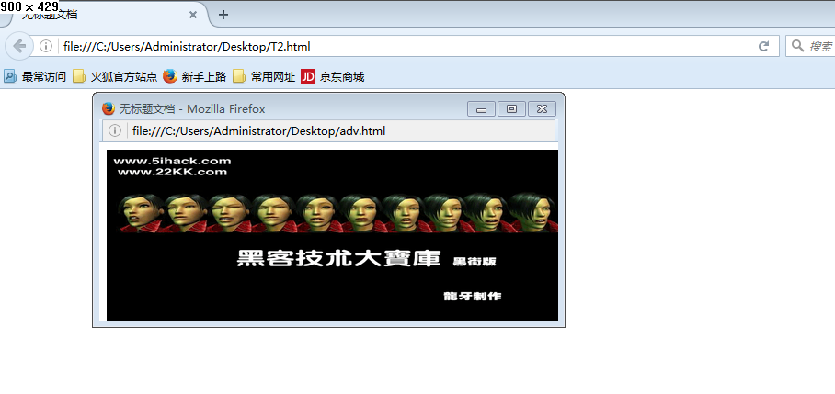

1. 每隔两秒钟切换网页标题

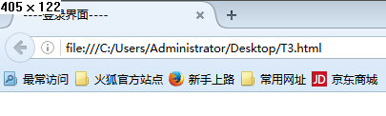

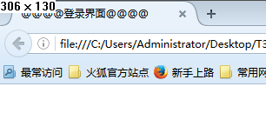

1. 清空购物车商品：当勾选“清空购物车”复选按钮时，下面所有的商品全部被选中，反之，全部取消。

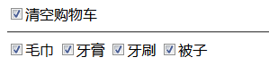

代码:

1.

<!doctype html>

<html>

<head>

<meta charset="utf-8">

<title>无标题文档</title>

<script>

function logs(){//登录按钮跳转到系统主界面才是

window.open("main.html");

}

function reg(){// 注册按钮跳转注册界面

window.status = "系统当前状态：您正在注册用户";

if(window.screen.width == 1024 && window.screen.height == 768){

window.open("register.html");

}else{

window.alert("请调整屏幕分辨率为1024x678，再打开");

}

}

function closss(){

if(confirm("确定关闭吗")){

window.close();

}

}

</script>

</head>

<body>

<center>

<input type="button" value="用户登录" onclick = "logs()"/>

<input type="button" value="用户注册" onclick = "reg()"/>

<input type="button" value="用户退出" onclick = "closss()"/>

</center>

</body>

</html>

2.

<!doctype html>

<html>

<head>

<meta charset="utf-8">

<title>无标题文档</title>

<script>

function openadver(){

window.open("adv.html","_blank","width=499,height=194,top=100,left=100");

}

</script>

</head>

<body onLoad="openadver()">

</body>

</html>

**Adv.html:**

<!doctype html>

<html>

<head>

<meta charset="utf-8">

<title>无标题文档</title>

<script>

window.onload=function(){

setTimeout("this.close()",2000);

}

</script>

</head>

<body>

<img src="img1.png" width = "499" height="194"/>

</body>

</html>

3.

<!doctype html>

<html>

<head>

<meta charset="utf-8">

<title>----登录界面----</title>

<script>

var t1 = "----登录界面----";

var t2 = "@@@@登录界面@@@@";

var index = 0;

function changeTitle(){

if(index % 2 == 0){

document.title = t1;

}else{

document.title = t2;

}

index++;

}

setInterval("changeTitle()",2000);

</script>

</head>

<body>

</body>

</html>

4.

<!doctype html>

<html>

<head>

<meta charset="utf-8">

<title>无标题文档</title>

<script>

function changes(){

var bt = document.getElementById("qin");

var checkboxarr = document.getElementsByName("thing");

for(var i=0;i < checkboxarr.length;i++){

if(bt.checked == true){

checkboxarr[i].checked = true;

}else{

checkboxarr[i].checked = false;

}

}

}

</script>

</head>

<body>

<input type="checkbox" id="qin" onclick="changes()"/>清空购物车

<hr />

<input type="checkbox" name="thing" />毛巾

<input type="checkbox" name="thing" />牙膏

<input type="checkbox" name="thing" />牙刷

<input type="checkbox" name="thing"/>被子

</body>

</html>